March 13, 2022
Subject: Officer Nominations and the 2022-2023 Term Election
Comrades,
One of the important issues facing the Post is nominations for the officers’ positions in March and election in April.
We have a wealth of experience, capabilities and assets in the ranks of our members. I ask each one of our members to take a personal assessment of their skills and knowledge to see how you can provide service to the Post and our local veterans.
Some of you have the leadership and management skills to fill the Commander, Senior Vice Commander or Junior Vice Commander roles. Others may have the organizational and bookkeeping skills to become our Quartermaster or Trustee. Perhaps you have background with VA information and can serve as the Post Service Officer assisting our local veterans. I implore you to seek out a role you’re equipped to serve and volunteer.
There are many opportunities to serve in our organization, but these will go unfulfilled if we don’t step up to the challenge. To paraphrase a quote from a past US President, “Ask not what the VFW Post can do for you, but what you can do for the VFW Post”.
We may no longer be in the active military, but we in the VFW are still serving our veterans.

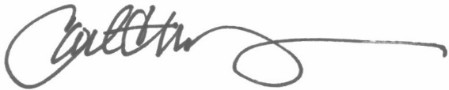
Carl Manchester
Past Post Commander
2019-2021

